**Grade 3. Unit 9.** Ms Ha 0772190006

1. Look at the pictures and letters. Write the words.

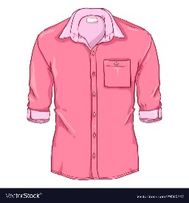

t r h i s

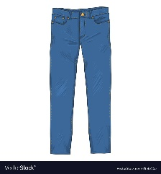

t p s n a s



f c r s a s

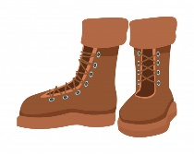

t o b s o s

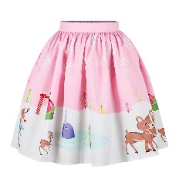

t r s k i

1. Write:
2. What are you wearing?

I ……. wearing a blue skirt.

1. What …….. he wearing?

He ……….. wearing a pink skirt.

1. What ……she wearing?

She…….. wearing red pants.

1. What …… .Tim wearing?

He……. wearing purple boots.

1. What …… Milly wearing?

She …….. wearing blue jeans.

1. What …… Grandma wearing?

He …….. wearing a yellow dress.

1. What ……. Mom and Dad wearing?

They ……. wearing black pants.

1. What ……. your sister wearing?

She …….. wearing a pink scarf.

1. What ……. he wearing?

…….. …….. wearing a black scarf.

1. What …… your brother wearing?

…… ……... wearing a blue pants.

